Studies carried out on concretes produced with LC3 according to Cuban standard NC 120: 2014
Eilys Valdés Alemán¹, Yosvany Díaz² and Fernando Martirena Hernández²
¹Faculty of Construction, Marta Abreu de las Villas Central University, UCLV, Santa Clara, Cuba
²Center for Research and Development of Structures and Materials (CIDEM), UCLV, Santa Clara, Cuba
evaleman@uclv.cu
Abstract
In order to implement the low carbon cement (LC3) as part of the Cuban regulations, a study of durability in concretes manufactured with this cement was developed, in different conditions of aggressiveness according to the performance parameters established in the NC 120: 2014 ''Hydraulic Hydraulic-Specifications'', the taking of witnesses of the H1, H2, and H4 concretes elaborated in 2016 was carried out. Carbonation depth tests, air permeability, chloride ion migration, were carried out. electrical resistivity, effective to determine the changes experienced by the series 1.5 years versus the series 6 months and the concretes made with cement under carbon LC3 compared to those made with Ordinary Portland Cement (CPO).
Subsequent to the analysis of the results, it can be verified that the concretes made with LC3 showed to be in a range of 11 to 16 times superior in their behavior to the electrical resistivity that those made with Portland cement and 15 to 22 times more resistant to the chloride ion penetration that those made with CPO, also show a more favorable performance with the passage of time.

Keywords: durability, concrete, low carbon cement (LC3), Cuban norm, exhibition sites.

1. Introduction
Concrete is man most used material after water. However, it did not prove to last as much as expected due to durability problems [1]. Most concrete is durable, but some aggressive conditions pose problems, particularly with corrosion of reinforcing steel due to chloride and carbonation leading to steel corrosion. [2].Recent studies have proven that concrete under aggressive conditions, such as marine environments, can have problems with chloride and carbonation.
For the implementation of a novel cement a standard for cement is required but in order to be able to use the cement, a durability standard should prove that concrete made with this cement stands aggressiveness conditions considered for the country/region[3], [4]
In the present investigation, a durability study is carried out in concrete made with a new kind of low carbon cement made with a ternary combination of Portland cement, calcined clay and limestone (known as LC3). Concrete blocks made with LC3 and Portland cement (as a reference) have been produced and laid at different exposure sites with different conditions of aggressiveness according to the performance parameters established in the NC 120: 2014 "Hydraulic Hydraulic-Specifications"[5]; and their durability has been assessed at different ages (6, and 18 months).
The testing protocol to be followed included: air permeability tests, electrical resistivity, resistance to chloride ion penetration by ASTM 1202, carbonation and water absorption.

2 Materials and experimental protocol

Concretes subject of study were produced with a ternary blend calcined clay-limestone-Portland cement, name LC3. A reference series was made with Cuban PC P35. Table 2.1 presents the properties of both cements.

Table 2.1: Properties of the cements used in this protocol
Cement | % >90 µm | Strength 2d Mpa | Strength 7d. Mpa | Strength 28d MPa
LC3-50 2:1 | 94.5 | 17.50 | 31.00 | 48.12
P35 |  | 18.20 | 40.00 | 58.90

Cylindrical specimens with size 35 x 50 cm were made with these cements. They were placed at different locations resembling the exposure conditions demanded by the Cuban standard NC 120:2014. Every 6 months cores were taken for studies at CIDEM, with the experimental protocol described in this paper. Concrete mix design were made considering prescriptive parameters of the Cuban standard. Results are presented at Table 2.2. Table 2.3 presents compressive strength results.

Table 2.2. Mix design used for PC and LC3 concrete. (Medina Sanchez, Ernesto)
Mix | Exposure class  NC 120:2014 | Strength  (Mpa) | W/C | Cem  (kg) | SP  (kg)  PC | SP  (kg)  LC3 | Sand  (kg) | Middle  (kg) | Coarse  (kg) | Water  (kg)
H1 | Very high | 35.0 | 0.40 | 430 | 3.87 | 8.6 | 634 | 352 | 775 | 172
H2 | High | 30.0 | 0.45 | 405 | 3.65 | 8.1 | 651 | 362 | 796 | 182
H4 | Low | 20.0 | 0.55 | 345 | 3.1 | 6.90 | 690 | 384 | 844 | 190

Table 2.3: Compressive strength in concrete made with LC3 and PC
Series | Cement  Kg | SP | A/C | Slump  cm | Compressive strength  (MPa)
 |  |  |  | P35 / LC3 | 3d  LC3 | 3d  P35 | 7d  LC3 | 7d  P35 | 28d  LC3 | 28d  P35
H-35 | 430 | 0.65% | 0.4 | 20 | 14.00 | 23.33 | 20.60 | 30.00 | 36.34 | 34.00
H-30 | 405 | 0.65% | 0.45 | 20 | 10.33 | 17.33 | 16.30 | 23.00 | 27.00 | 28.00
H-25 | 370 | 0.65% | 0.5 | 20 | 7.66 | 14.33 | 15.00 | 18.60 | 22.33 | 23.00
H-20 | 340 | 0.65% | 0.55 | 20 | 7 | 12.00 | 12.00 | 14.70 | 18.57 | 19.66

2.1 Exposure sites

Punta Matamoros (Cayo Santa María).
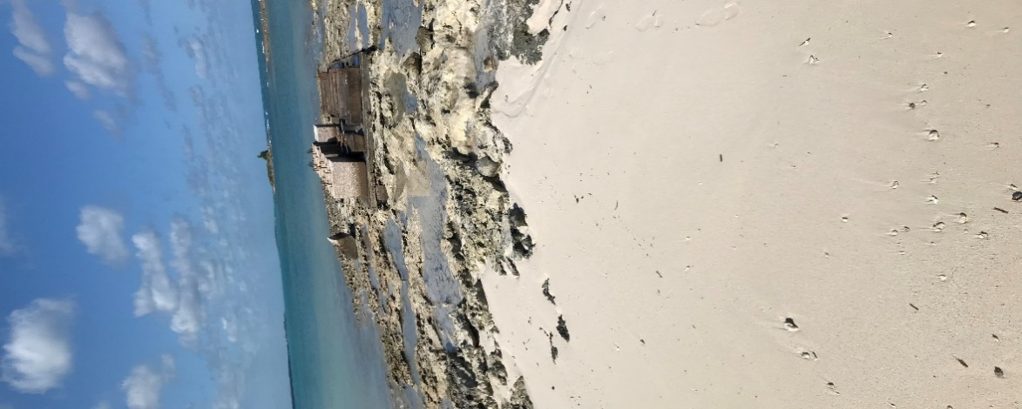
This site is located at the central region of Cuba, on the northern coast of Villa Clara. [6] It has two concrete platforms each of approximately 40 m² for exposition. This is the most aggressive environment in Cuba.

Fig. 2.1. Exposure site Punta Matamoros, Cayo Santa María

Sede Universitaria (Cayo Santa María).
This site is situated at some facilities of the university in the area. It has a 20 m² platform and is situated at approximately 1500 m from the sea side. This is considered high aggressiveness.

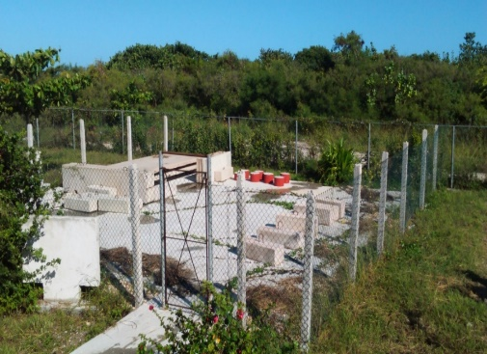

Fig. 2.2. Exposure site Sede Universitaria Cayo Santa María

Faculty of Constructions (UCLV).
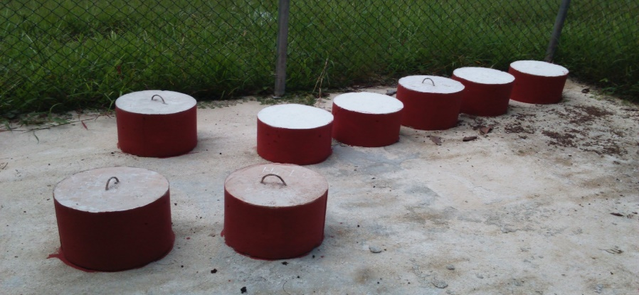
It is located at CIDEM’s facilities at the university, at more than 20 km from the seashore. This área is considered low aggressiveness. (Series H4).

Fig. 2.3 Exposure site Faculty of Constructions

2.2 .Testing protocols
- Measurement of surface resistivity of fully saturated concrete cores. A four-point probe was used -Wenner probe-; four equally spaced electrodes are placed on the concrete surface. An AC current is injected through the outer two electrodes, and the voltage drop is measured between the two inner electrodes [7]
- Measurement of air permeability of concrete cores using the Torrent method: it measures the coefficient of air-permeability kT with the PermeaTORR instrument. [8] The coefficient of air-permeability kT (10-16 m²) is calculated as function of the increase in pressure recorded in the measuring chamber.
- Carbonation depth, measured by spraying the exposed surfaced with phenolphthalein. Cores of the elements were taken. The cores were split in two parts so have the carbonated part exposed [6], [9].
- Rapid Chloride permeability test (RCPT) according to the procedure described at ASTM 1202, which determines the total charge passing. [10]
3. Discussion of results

3.1 Air permeability tests.

In figure 2.4 it can be seen that the specimens of the series 1.5 years show better behavior than those of the series 6 months, unlike the concretes of the series H2 CP and H1 LC3 the latter with irrelevant differences.

Fig.2.4 . Comparison of air permeability results (Series 1.5 years and series 6 months)

The above comparisons allow us to determine that after its exposure to the medium, the passage of time has a positive influence on the permeability of the concrete when the hydration reactions are completed, since the best results were obtained with the series 1.5 years, on the other hand, the concretes made with LC3 showed to have better permeability behavior than those made with Portland cement.

3.2 Resistivity tests.

Figure 2.5 shows, concretes with LC3 increase their electrical resistivity considerably over time. In the case of concretes made with CPO, no noticeable increase in electrical resistivity is observed.

Fig. 2.5 Comparison of resistivity results (series 1.5 years and 6 months)

The above comparisons allow to affirm that the passage of time has a positive influence on the electrical resistivity of the concretes made with LC3, however, in those manufactured with CPO this property does not show variations with the passage of time (series 6 months to series 1.5 years), in addition, the concretes made with LC3 showed to be in a range of 11 to 16 times better in terms of their behavior to resistivity than those made with Portland cement.

3.3 Chloride ion penetration resistance tests according to ASTM 1202.

Figure 2.6 shows that the 1.5-year series decreases the chloride ion permeability of concretes made with LC3 compared to the 6-month series. In concretes made with Portland cement, only improvements of 310 Coulomb in the chloride ion permeability for the H4 samples are observed.

Fig. 2.6 Comparison of chloride ion penetration resistance results by ASTM 1202 (series 1.5 and series 6 months).

With the passage of time, the chloride ion permeability of the concretes that used LC3 for its elaboration decreases since the series 1.5 years presents the lowest values for the evaluation of this parameter. The concretes produced with LC3 are more resistant to chloride ion penetration than those made with CPO in a range of 15 to 22 times.

3.4 Analysis of carbonation results.

Figure 2.7 reveals that in the series 1.5 years there is a greater depth of carbonation than in the series 6 months, both for specimens made with LC3 cement and those made with Portland cement, this is justified by the longer time of exposure to the medium.

Fig. 2.7 Comparison of carbonation depth results (series 1.5 and series 6 months).

It is appreciated that LC3 specimens have a greater depth of carbonation than those of CPO, according to previous research, it is because the carbonation in concretes produced with LC3 advances quickly in the first months and then stabilizes until presenting a practically constant over time, while in concretes made with CPO the advance of carbonation starts at 0 and increases in a measured way throughout the life of the concrete.

4. Conclusions
- Concrete made with LC3 can be used in any of the aggressiveness conditions prescribed in the Cuban standard NC 120:2014, since all results are favorable.
- Concrete made with LC3 show a better performance in terms of chloride ingress and permeability, but they have a slight increase in carbonation rate.
- At late ages, LC3 concrete continues to improve its properties.

References
[1] G. M. Idorn, “Innovation in concrete research — review and perspective,” Cem. Concr. Res., vol. 35, no. July 2002, pp. 3–10, 2005.
[2] The European cement Association, “The role of CEMENT in the 2050 LOW CARBON ECONOMY,” 2014.
[3] R. D. Hooton, “Current developments and future needs in standards for cementitious materials,” Cem. Concr. Res., vol. 78, pp. 165–177, 2015.
[4] R. D. Hooton, “Bridging the gap between research and standards,” Cem. Concr. Res., vol. 38, no. October 1995, pp. 247–258, 2008.
[5] NC-120, Hydraulic concrete -specifications Cuba. 2014.
[6] A. Cebey Liquor, “Evaluation of carbonation in concretes made with low carbon cement LC3,” Universidad Central de las Villas, 2016.
[7] U. M. Angst and B. Elsener, “On the applicability of the wenner method for resistivity measurements of concrete,” ACI Mater. J., vol. 111, no. 6, pp. 661–672, 2014.
[8] S. 262/1:2913, Bauwesen Betonbau – Ergänzende Festlegungen. 2013, pp. 1–52.
[9] K. NAZCO, “Evaluation of Cuban multicomponent clays as source of raw material for the production of supplementary cement materials,” Universidad Central de las Villas, 2014.
[10] ASTM-C1202, Standard Test Method for Electrical Indication of Chloride’s Ability to Resist Chloride. 1994.

