Considerations for the energy balance and preliminary design of an experimental LC³ Cement Pilot Plant.
Authors: Dr. Ing. Machado L.I¹.; MSc Bacallao¹, F.; Dr. Ing. Moya I. H²; Dr. Sc. Ing. Martirena F¹.
¹ Central University Marta Abreu de Las Villas, Center for Research and Development of Structures and Materials (CIDEM) ivanm@uclv.edu.cu

ABSTRACT
Associated with cement manufacturing processes, large amounts of carbon dioxide (CO₂) are released into the atmosphere, it is estimated that between 0.65 - 0.90 tons of CO₂ are emitted per ton of cement manufactured. By 2050, the demand for this binder is expected to exceed 5,000 million tons, which would contribute to an increase of more than 3% of emissions.
However, the emissions can be reduced by using supplementary cementitious materials (SCM), in this sense the calcined clays have a great potential for the reduction of emissions in the manufacture of cement, has been studied in recent years’ low carbon cement or LC³, developed by a joint team of the University of Lausanne and the Central University of Las Villas. The main results are the expansion of production by achieving clinker substitutions of up to 50%.
In this sense, the Center for Research and Development of Technologies and Materials (CIDEM) in conjunction with the company IPIAC-NERY has committed to the development of a small pilot plant that makes the manufacture of limited quantities of LC³, which allows the study of the process by interacting different sources of raw materials.
In this paper some calculations were for designing a pilot plant, taking into account the balance of mass and energy necessary for its proper functioning, which in turn allows to specify the technology for the scaling of the production in any new industrial plant or adaptation of capacities installed.
Keywords: mass, energy, low carbon cement, clay.
1 - Introduction
A new technology based on the replacement of clinker by high volumes of supplementary cementitious material, in this case thermally activated clay (TAC, in Spanish AAT), has been investigated in recent years by researchers of the international team "Low Carbon Cement". The new proposal is officially recognized by the scientific community as LC³, whose results and advances are documented in scientific journals, being in this sense very important the expansion of production to achieve clinker substitutions of up to 50%. (Vizcaíno 2015).
The LC³ is an appropriate option because it considerably reduces CO₂ emissions into the atmosphere by reducing energy consumption, which is economically advantageous (Dairon 2017) Recently through the management of IPIAC NERY the demand for LC³ commercial production plants has skyrocketed. However, perform the essential industrial tests, although necessary to perform tests in real conditions can be very expensive.
In this sense, this work exposes some elements of the design of a small pilot plant where tests can be carried out in industrial conditions, with the advantage of obtaining reduced yields, however, these small plants replicated in a conscious way can be equivalent to the investment in a large cement plant. The first IPIAC - CIDEM plant will be put into operation in facilities of the Central University of Las Villas, its location is shown in figure 1.

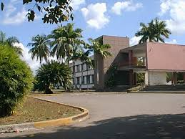
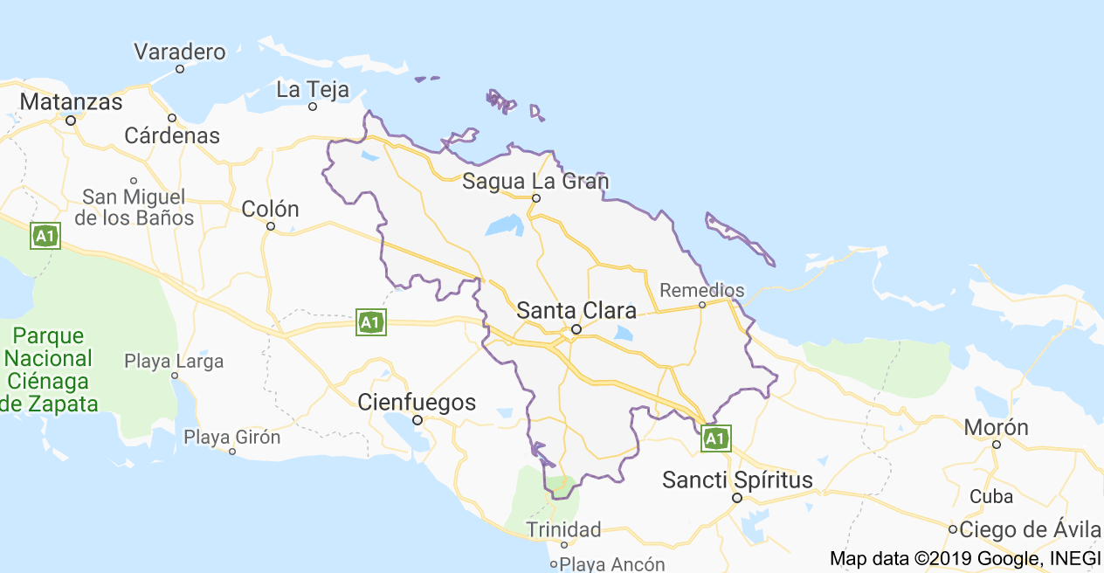
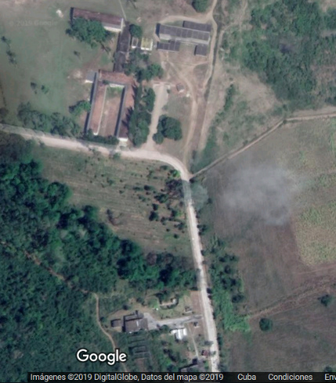

Figure 1. Location of the pilot plant IPIAC - CIDEM. Central University of Las Villas. Faculty of Constructions, Villa Clara, Cuba.

The balance of mass and energy that is established in the calciner by achieving the thermal modification of the clay is also analyzed. At temperatures between 100 and 400ºC approximately, clay minerals give up their free water (not combined) and adsorbed water, including interlaminar water, at higher temperatures, between 400 and 750ºC, and depending on the types of clay minerals present in the raw material, water combined chemically in the form of hydroxyl groups is released (dehydroxylation).
In the case of kaolinite, the process of mass loss of the material during thermal activation is defined as a function of the activation temperature by the following expressions. (Orihuela 2007)
Al₄ [(OH)₈Si₄ O₁₀ ] |  | 2 (Al₂ O₃ · 2SiO₂) | + 4 H₂O | ………...............(1)
Al₂ O₃ . 2SiO₂ (OH)₄ |  | Al₂ O₃ + 2 SiO₂. | + 2 H₂O | ………………….(2)

In the dehydration of clays influence factors, such as the type of clay minerals, the nature and quantity of impurities, the size of the particles, the degree of crystallization of the clays, the gaseous atmosphere, and others.
The pilot plant IPIAC - CIDEM for the design of experimental tests is conceived to obtain a production flow of TAC of 100 kg / h by dry process, in this work to facilitate the design tasks in terms of mass and energy balances. Data are obtained from the bibliography consulted or from estimates made. The theoretical - methodological approach is exposed to perform the mass and energy balance, within the control limits determined for the kiln system. Figure 2 shows the flow of the process established in the pilot plant for the production of LC^{3.}
2 - Analysis and results:

An optimal design of the rotary kiln can considerably reduce the assembly cost of the plant from the initial assumption of the desired production levels. Table 1 shows a summary with the projection in time of the expected production level.

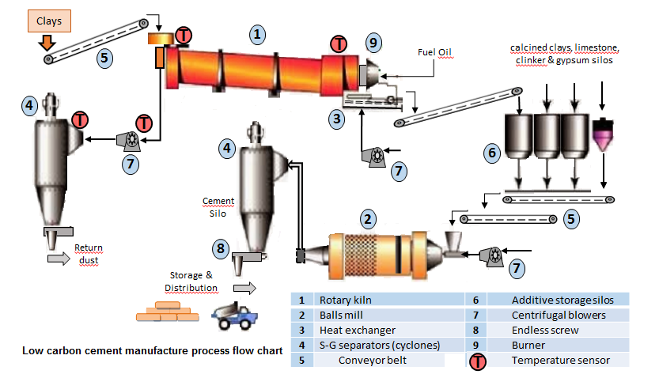
Figure 2 Flow of the process established in the pilot plant for the production of LC³ Source: Esparza, G.

Table 1 Estimated TAC production when carrying out the design calculations of the pilot plant IPIAC – CIDEM. Source: Self-made.
Productivity  calcination - TAC |  | CaCO₃ | LC² | P35 | LC³
100 | Kg/hours | 67 | 167 | 167 | 333
800 | Kg/ 8 hours | 533 | 1333 | 1333 | 2666.7
2400 | Kg/ 24 hours | 1600 | 4000 | 4000 | 8000
72000 | Kg/month | 48000 | 120000 | 120000 | 240000
720000 | Kg/year | 480000 | 1200000 | 1200000 | 2400000
720 | Tons per year | 480 | 1200 | 1200 | 2400

2 a) The rotary kiln. Sizing

The rotary kiln consists of a cylindrical tube resting on rolling stations, which has a certain slope with respect to the horizontal and which rotates at speeds of rotation between 1.8 and 3.5 revolutions per minute (rpm).
The slope is determined for which there is no rigid rule, its value ranges between 2 - 6%, most furnaces are installed with slopes between 2 - 4% in relation to the horizontal. As a result of the experience of operating rotary kilns, the optimum ratio between slope and filling coefficient (φ) has been obtained (DUDA 1977).
For the present design, a slope of 2º is established with a coefficient φ of 11%. In addition, the revolutions per minute (r.p.m.) of the rotary kiln will be in the order of 2.5 r.p.m. and a flow rate of 0.045 m3 of clay / hours.
The calculation of different furnace design parameters is based on the law of transport of material inside an inclined rotary tube given by the US Bureau of Mines, which is expressed by the equation 1:
…………………………(3)
Where: Q: transport capacity per hour (kg / h), n: speed of rotation (r.p.m.)
Di: inner diameter (m), Φ: filling degree, ρ𝑎: density of the material
β: movement of the resulting material (degrees º).

Transformed (1) it is possible to obtain an expression for the determination of the inner diameter of the calciner rotary kiln according to 2, (F. G. Colina 2016):
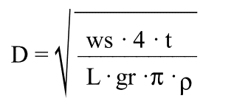……………………………..(4)
Where: ws: Solid flow (kg / min). L: Length of the kiln (m).
gr: Furnace filling degree (%). p: kiln slope (in%).
t: Total time of residence of the material inside the kiln (min)
The residence time of the clay material that has to be dehydroxylated is possible to obtain it from equation 3, however, there are many other expressions for the calculation of the residence time (Duda 1977). The residence time will determine the flow of material inside the oven, so this is one of the basic parameters for the design. When setting this variable, others can be calculated for the sizing of the kiln.
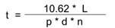…………………………………….(5)
Where: t: time of permanence (minutes). L: length of the rotary kiln (m).
d: inner diameter (m). n: rotation speed (r.p.m.).
p: inclination slope of the kiln.
The residence time is inversely proportional to the rotation speed and diameter of the kiln, being directly proportional to the length of the oven. The length and diameter of the furnaces are related by empirical laws such as L / D = 10 - 13, for long furnaces with different types of support, however prototypes with relation 4-12 can be found (Aros Oñate 2010), in this work we have opted for a relationship in the environment of 5. Table 2 shows the values ​​of the coefficients and factors assumed, as well as the final dimensions adopted.
Table 2 Main working parameters and dimensions of the rotary kiln IPIAC - CIDEM for obtaining thermally activated clay. Source: Self made
Di | L | t | Q | n | ν | φ | p | β
0.42 | 3.745 | 11 | 100 | 2.5 | 2 | 11 | 2 | 2.751

2 b) Thermal design.
The analysis of the flow processes begins with the choice of the spatial region called "control volume." In the diagram represented in figure 3, the border or edge of the analysis performed in this work is shown.
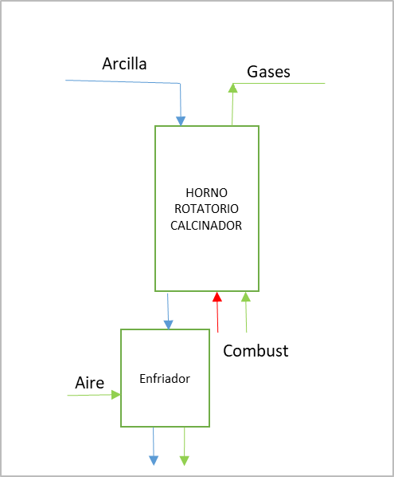

AAT
Clay
TAC
cooler
Rotatory Kiln
Fuels
Air
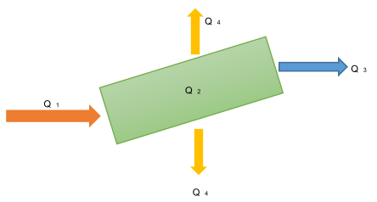

Figure 4 Energy balance. Source: Self made

Figure 3: Calcination of clays in a pilot plant. Analysis and borders. Source: Self made

The thermal balance is defined from the mass balance that occurs in the process, taking into account the elimination of free water and adsorbed water (up to 400 ºC), and in the decomposition or loss of the OH- of the clay ( up to ≈ 850 ºC), given by the equations described above (see 1 and 2). The loss of mass due to the natural humidity of the clay is approximately 6 - 7% and also the loss of mass due to decomposition or dehydroxylation of clay is 14%
Thermal balance is essentially conducted based on energy and mass conservation laws.
E_{in}=Eout…………………………………………………………………………………………………………...(6)
E_{in}= Q₁= E_{out} = Q₂+Q₃+Q₄ ……………………………………………………………………(7)
Where: Q₁, Heat delivered to the kiln; Q₂, Heat needed for the clay transformation process; Q₃, Heat losses with the hot gases through the chimney; Q₄: Radiation heat losses.
Q₁=m_{F}*LHV/ηcomb…………………………………………………………………………………….(8)
Where: m_{F,} Fuel mass in kg/h; LHV, low heating value (MJ/kg); η_{comb}, combustion efficiency adopted for this case 90%.
Q₂= K_{cap}*Qe……………………………………………………………………………………..………….(9)
Where: K_{cap,} is the kiln capacity in kg/h in this case kiln capacity is 100kg/h; Q_{e} is the specific energy needed for clay transformation in the sinterization process, in this case is adopted the value of 0,81 MJ/kg reported by Mayorga (Mayorca, 2000).
Q₃ = 0.001*m_{g}*$\overline{Cp}$*∆t………………………………………………..……………………………(10)
Where: m_{g} is the exit gases mass in kg/h; $\overline{Cp}$ in the average specific heat of the exit gases in the given window temperature in kJ/kgK; ∆t is the difference of the exit gases temperature (t_{out}) and the environment temperature (t_{env.}).
Q₄ = 0.11*Q1……………………………………………………………………………………………………(11)
The resolution is summarized in table 3. Calculated the fuel mass consumption can be completed the thermal balance, as shown in table 4.
Tab. 3 Calculation result and data
Results, Data | Value
m_{F} (kg/h) [lts/h] | (3.16) [3.76]
Kcap (kg/h) | 100
Tg_{out} (°C) | 600
T_{env} (°C) | 29
Q_{e} (MJ/kg) | 1
LHV (MJ/kg) | 42.8
η_{comb} | 0.9
Radiation losses | 0.11
m_{e} (kg/kgF) | 17
$\overline{Cp}$ (kJ/kgK) | 1.10
Tab.4 Thermal balance results
Balance | Value | Share
Q₁ (MJ/h) | 150.3874 | 100%
Q₂ (MJ/h) | 100 | 66%
Q₃ (MJ/h) | 33.8448 | 23%
Q₄ (MJ/h) | 16.54262 | 11%

Conclusions
The design of a rotary kiln for the treatment and thermal modification of clays is advantageous since this technology allows continuous production, by obtaining the optimal sizing according to the desired productivity and characteristics of the material to be obtained, the best behavior of parameters such as fuel consumption and heat losses can be used, extrapolated, for the design and construction of facilities with diverse production capacities.
Bibliografy
- Aros Oñate, N. (2010). Control predictivo no lineal de un horno rotatorio Ier Congreso Iberoamericano de ingeniería de proyectos, . Antofagosta, Chile.
- Escuela Politécnica Nacional. Trabajo de Diploma.
- Dairon, J. A. C. (2017). Evaluación económica y ambiental de plantas prototipo de pequeño y mediano tamaño para la producción de cemento LC³. . Facultad de Construcciones. CIDEM. . Santa Clara. Cuba. 2017. , Universidad Central Marta Abreu de Las Villas. . TD.
- Dpto. técnico IPIAC, N. (2018). Estimación del consumo de combustible. Torres Nova, Portugal:
- DUDA, W. (1977). Manual tecnológico del cemento. Traducido por Antonio Sarabia González. España: Editores técnicos asociados.
- F. G. Colina, I. C. y. J. C. (2016). "Diseño básico de hornos rotatorios para el tratamiento de minerales." Ingenieria Quimica. Julio/ Agosto 2016 Dpto. de Ingeniería Química y Metalurgia. Universitat de Barcelona.
- Orihuela, E. M. (2007). Análisis energético de las diversas alternativas aplicables a una planta de clinkerizacion y producción de cemento. . Ingeniería Energética y Mecánica de Fluidos. Escuela Superior de Ingenieros. . Sevilla. , Universidad de Sevilla. . TD.

